Moves
M: slice move, follows the L direction

Corners
Name | Case | Algorithm
Diagonal: all different  ↴ ↰, ↰ ↴ | 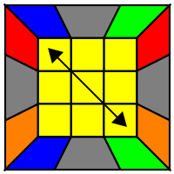 | F (R U' R') U' (R U R') F'  (R U R') U' (R' F R F')
Headlights  ↰ ↴, ↴ ↰ | 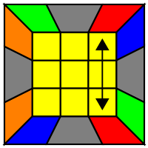 | (R U R') U' (R' F R F’)  F (R U' R') U' (R U R') F'

Edges
Name | Case | Algorithm
Right center to left | 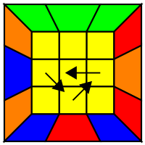 | R U' (R U R U R) (U' R' U' R2)
Left center to right | 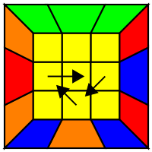 | L’ U (L’ U’ L’ U’ L’) (U L U L2)
Opposite edge swap | 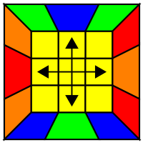 | M2 U M2 U2 M2 U M2
Adjacent edge swap | 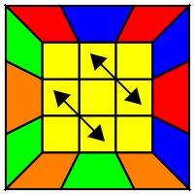 | M' U M2 U M2 U M' U2 M2
Source: https://jperm.net/algs/2lookpll

Corners training scrambles
- Diagonal:
  - initial: B F U2 B F' U' R2 U L2 D' L2 U' F2 D L2 D' R2
  - repeat: U' F B' U2 F' B U2 L2 F2 U F2 U2 L2 U' F2 U2 F2 L2
- Headlights:
  - initial: U' R L U2 R L' U F2 L2 B2 L2 F2 D' R2 D B2 U' R2
  - repeat: B F U2 B F R2 U F2 L2 D B2 U' F2 R2 D' R2 B2 F2

Edges training scrambles
- Right center to left: U2 R2 U' F2 R2 F2 U R' L F2 D2 B2 U2 R L B2 D2
- Left center to right: U2 B2 U R2 B2 R2 U R2 U2 R2 U2 B2 R2 B2 U2 B2
- Opposite edge swap: U F B D2 F B D2 F2 R2 D2 R2 B2 L2 U2 F2 L2
- Adjacent edge swap: U R L U2 R L' U B2 R2 B2 U R2 U B2 R2 B2 U R2

Adjacent Edge Swap Parity on 4x4
- R U R’ U (parity) U R U’ R’
- Parity: r2 U2 r2 Uw2 r2 Uw2

