First layer star
- Intuitively

First layer corners
- Like the 3x3 cube first layer corners:
R U R’ U’

Second layer edges
- Like the 3x3 cube second layer edges

3rd layer corners and edges: teardrop
- Start with the orange side: left, corner, right
- Last side: solve it by rotating it one step back, then rotate it into place

Fourght layer corners and edges
- Like the 3x3 cube first layer corners and second layer edges

Last layer edges
- Orientation: F R U R’ U’ F’, the already good edges form a horizontal line, they turn left if necessary
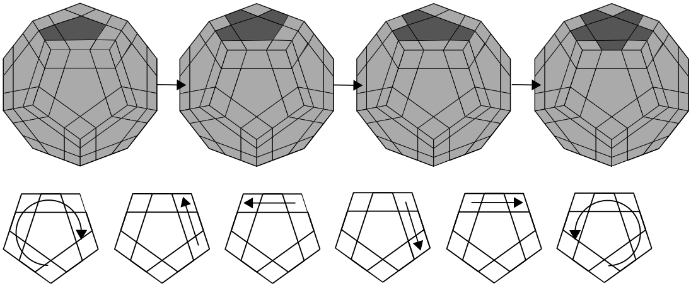
- Permutation: R U R’ U R U3 R’
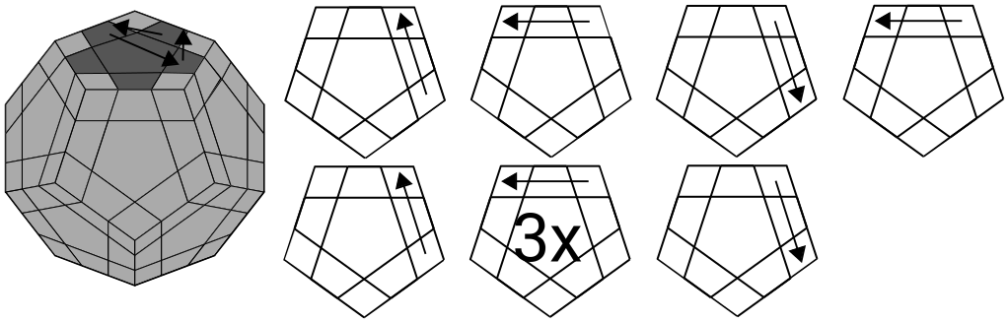

Last layer corners
- Permutation: upper, right, right down corners can be swapped
R U’2 L’ U2
R’ U’2 L U2
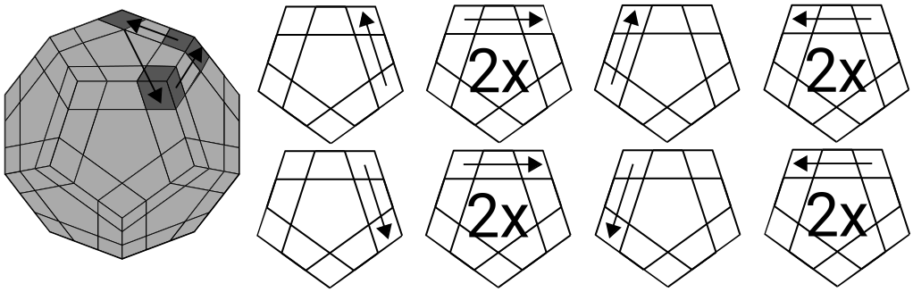
- Orientation: upper face right bottom corner rotation
R’ RD R RD’
R’ RD R RD’
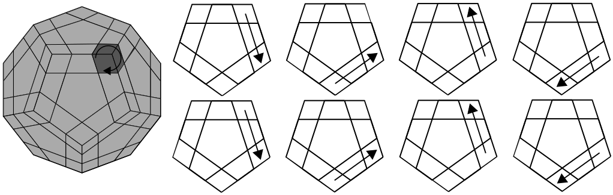
Source: https://de.speedcube.com.au/blogs/speedcubing-solutions/how-to-solve-a-megaminx-layer-by-layer-easy-to-follow-beginners-steps

